Java JRE and JDK installation on Ubuntu

> sudo apt install openjdk-8-jdk # java binaries and complier installed

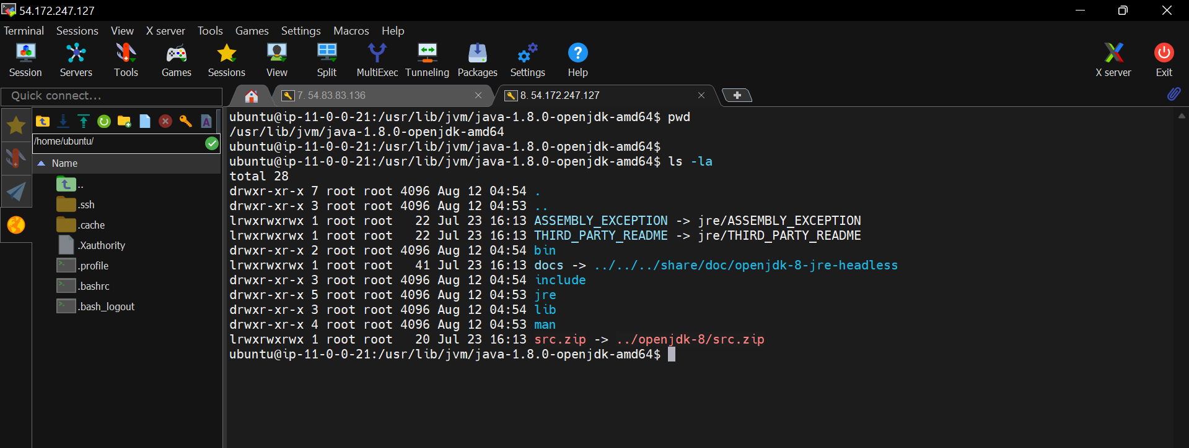

Java JRE and JDK both libraries are installed.

> sudo apt install openjdk-8-jre # java JDK libraries and java complier(javac) are not installed

Java JRE and JDK installation on amazon Linux/red hat

> sudo yum install java-1.8.0-openjdk # java binaries and compiler not installed, only JRE installed

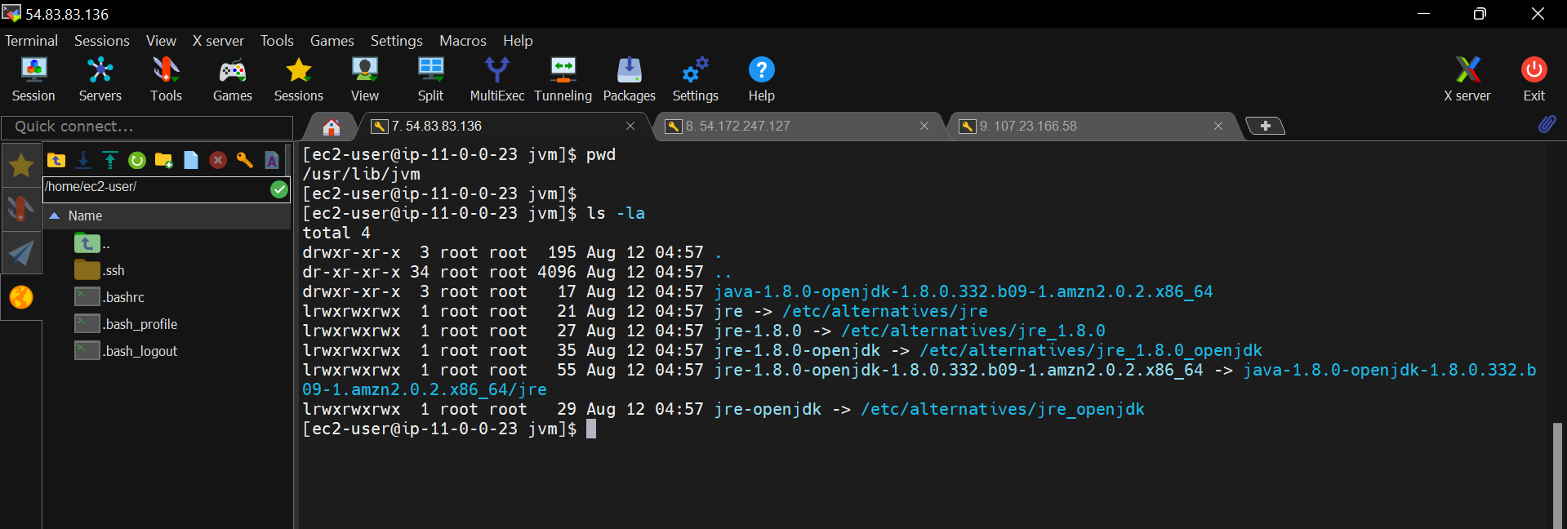

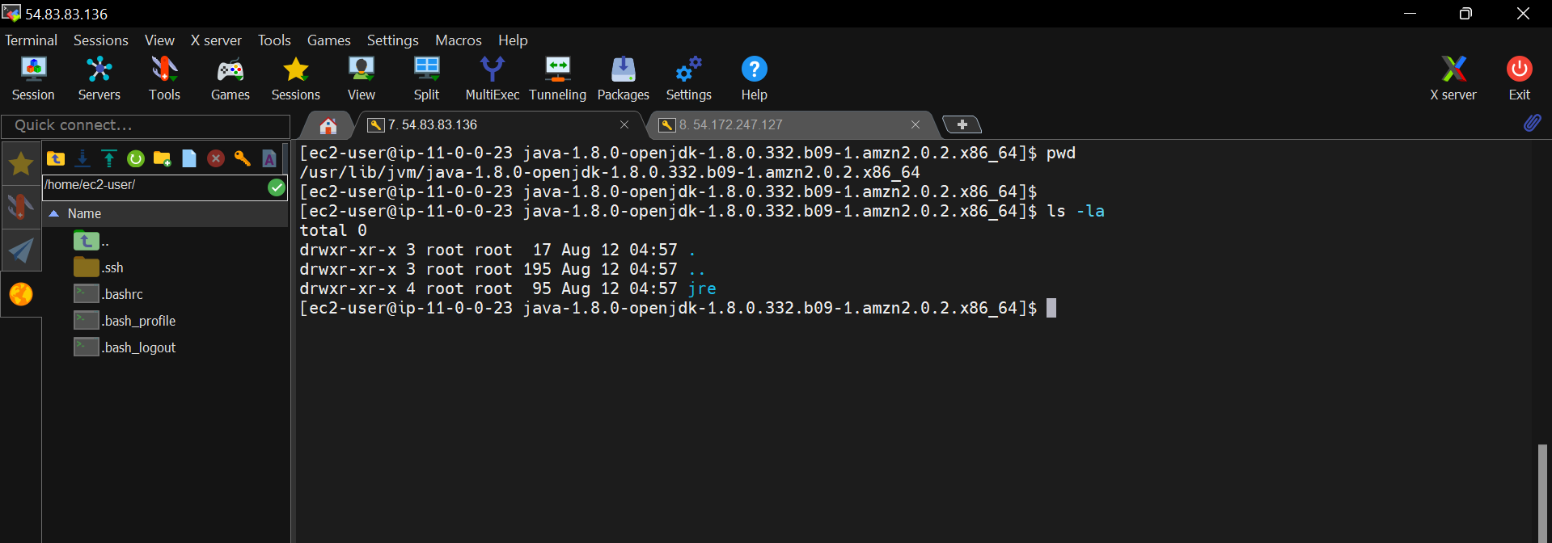

Only JRE libraries are installed. JDK libraries are not installed.

> sudo yum install java-1.8.0-openjdk-devel

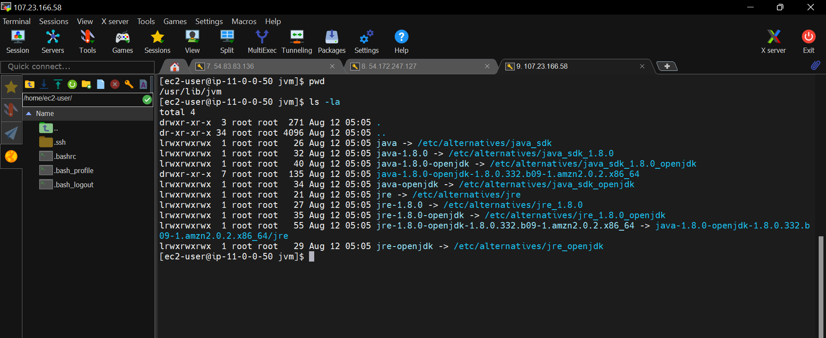

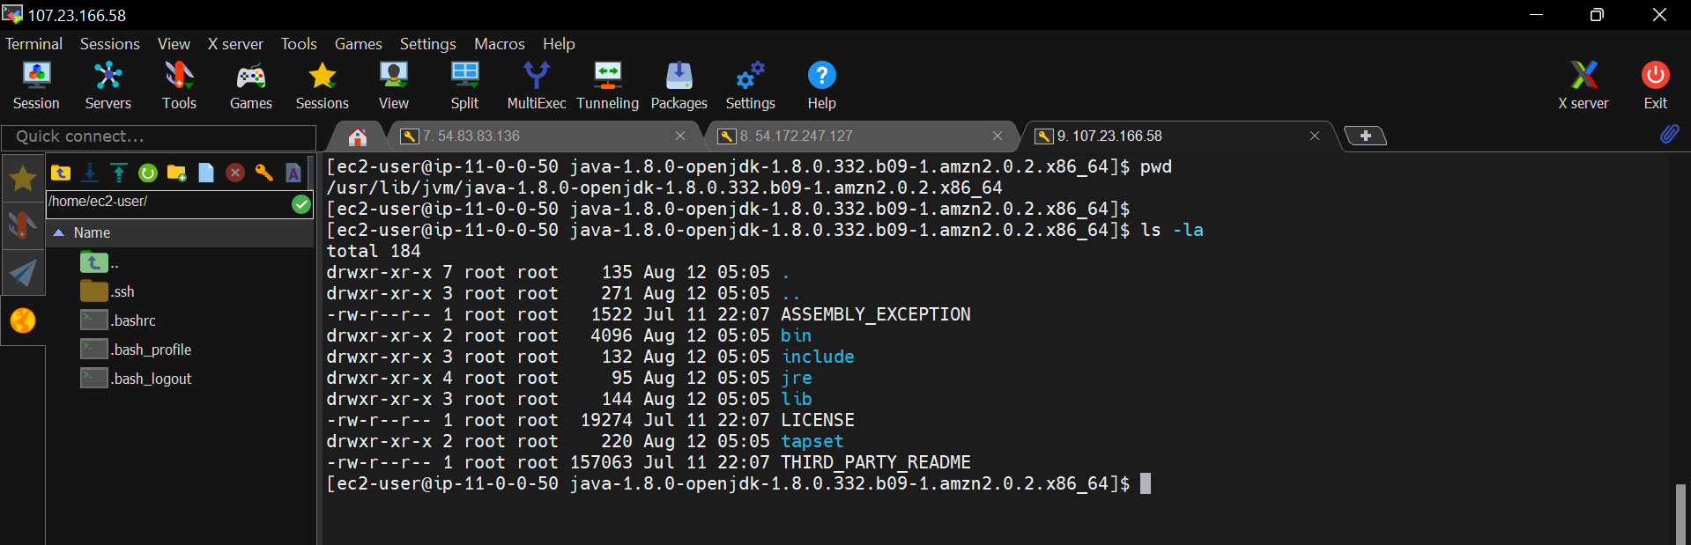

JDK and JRE both libraries are installed.